

**MEMORANDUM**

|  |  |  |  |  |
| --- | --- | --- | --- | --- |
| To: | Assoc. Prof. Ir. Dr. Rosdiazli Bin Ibrahim  Dean  Centre of Graduate Studies | | | |
| Through:  Supervisor &  Co-Supervisor | Dr Noreen Izza Bt Arshad  Associate Professor  Department of Computer & Information Sciences  Dr Aliza Bt Sarlan  Head of Department  Department of Computer & Information Sciences | | | |
| From | Maryam Ahmad  ID : 20000052  Department of Computer & Information Sciences | | | |
| Ref: |  | Date | : | 9/03/2022 |
| Subject: | **Appeal to Convert from GA to TFA Scheme** | | | |

Respected Sir,

Regarding the subject mentioned above, I would like to request to convert my GA, which was discontinued from 28/8/2022 due to completing 2 years of my study.

Since I have GA hours that are still being completed almost every month, I would like appeal to convert my GA to TFA Scheme. I’ve just began to write my thesis and I’m hoping to complete it in a deadline before the end of my candidacy period. This will allow me to complete my work and submit it for viva in the best possible way.

Yours sincerely,

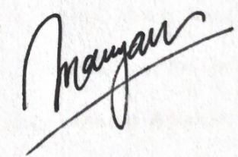

**Maryam Ahmad**

20000052

Department of Computer & Information Sciences

Universiti Teknologi PETRONAS